Title or Task: | Title Digital Convergence  

Description:

Files Required
Suitable for Classes: | All classes Y11 AIT 2a & 2b
Area: | Technology & Enterprise
Teacher: | Mr Peter Faulks

Timeline

Date Due:

Task Brief:

Outcomes:

THIS IS HOMEWORK
Consider each of the following questions.
Use a new word processing application to answer each question. (You may need to use reference books or the Internet to assist you).
- Make a list of at least six analogue devices and products that you know have been replaced by digital alternatives.

Analogue | Type, mechanical, analogue, digital etc. | Digital alternatives | Type, i.e. Electronic, wireless, touch etc. | Notes

- Discuss at least one item of technology that has been affected by digital convergence.
- Comment on how these changes have affected the way you work, learn and have fun.
- What effects do you think digital convergence will have on newspapers, television and music?
- List some disadvantages of digital convergence. Comment on the cost of upgrading computer hardware and software to meet the demands of new products.
- Create a cover page that also shows your understanding of Digital Convergence.

Save your work as (your initials) _digital_convergence into your AIT Marking folder and put a link in your site.

Notes to help you

Analogue vs digital
The term analogue relates to a system or device in which data is represented by continuously variable, measurable quantities. Some examples include length, width, voltage or pressure. The important things to remember about analogue systems or devices are that the data they represent can be measured continuously.
Think of a traditional glass thermometer. The mercury inside the glass rod gives a measurable value for temperature. The current temperature can always be determined because the mercury is always visible up to that point.
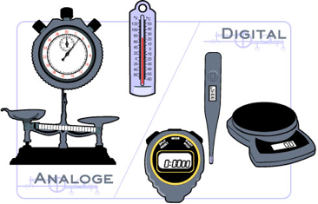
A digital thermometer on the other hand will only display the current temperature in whole degrees or parts thereof. It will not depict the temperature as a continuous measurement.
A digital system or device is one which uses discrete values rather than continuous values. Computers operate as digital devices by distinguishing between just two values, o 0 and 1 or, off and on.
For a computer to process analogue data, it must first be converted into a series of digits. The process of converting analogue values into digital values is called digitisation.
What does this mean? If you were to scan in to your computer a watercolour painting, the computer would break up the continuous source of visual information (the light reflected off the painting from the scanner) in to a series of number values. These number values can be read by a computer to recreate a digital version of the water colour painting.

Digital convergence
Is the merging of common digital devices within personal computer (PC) technology, making them more accessible, affordable and useable etc.
Through digitization nearly everything can be converted to numbers and processed by a computer. Every type of media: photographs, sounds, music, books, movies, letters and newspapers can become digital and therefore distributed and consumed in ways never before possible. The process by which these media are digitized and delivered across computer networks is called digital convergence.
Digital convergence influences how society communicates, learns, works and plays. The advantage of media that has been digitized is its flexibility. Digital files can be compressed, (like an MP3 music file), manipulated (like photographs) or made interactive (like the menu on a movie DVD).
Digital convergence is driven by large commercial companies who see the future in multipurpose personal digital devices, such as portable media players. Digital convergence has been described as ‘the art of bringing computing and consumers together’.

Advantages of digital convergence
The first advantage of digital convergence is that digital products are very cheap to make.
Consider the cost of producing an online digital book compared to a printed copy available in the book store. The printed book requires the production of paper from forest products. The pages of the book need to be ‘set out’ ready for the printing press, along with any artwork. The printing process requires specialised equipment and trained operators. Printing and binding a book can take several days before it is ready for distribution to bookstores. The distribution requires transport networks and vehicles to deliver the books to the store, as well as an ordering system.
In the digital world, there is only one copy of the book produced. It doesn’t need to be printed or bound. It is placed in a database on a computer network and from there anyone with access to the network can obtain a copy of the book. The cost of printing and distribution is paid for by the consumer. From the time the author finishes the book to the time the consumer reads it is negligible. In fact, some authors are releasing their latest books one chapter at a time over the web. The ability to consume a digital product is almost immediate.
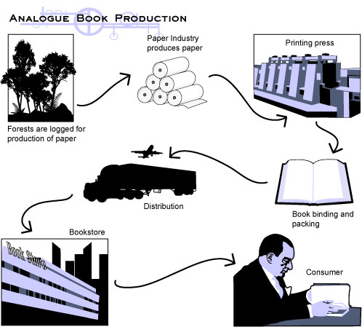

The second advantage of digital convergence is quality. Digital versions of products don’t degrade with use or reproduction. | 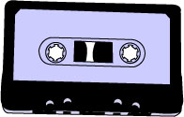

Before the introduction of the Compact Disc, music was distributed on tape cassettes. The cassettes used a ribbon of tape wound on spools in the same way as a video tape. The equipment used to play the tape contributed to its degradation. The more times the tape was played the worse the quality became.

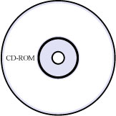 | With digital recording came optical playback using lasers. The use of a laser to read digital information on a disc meant that the surface of the disc was not damaged by continued use. Add to this the fact that every piece of information stored on the disc is read and processed exactly as it was recorded, the quality of digital storage is clear.
Computers and software can refine the digital signal further. Using special programmes to remove noise, means that digital recording and playback provides a higher quality product. Given the right hardware and software, digital copies of music and images can be so good, they are indistinguishable from the originals.
The third advantage is portability and transmission.
With advancements in communication networks and the materials used to make wires and cables, digital files can be transmitted at the speed of light. The extensive use of fibre optic technology in communication has made it possible to transmit digital information between any two places almost instantly. Where wires can’t be used, radio waves can broadcast digital signals. In the future, almost every device will be communicating within a computer network.

